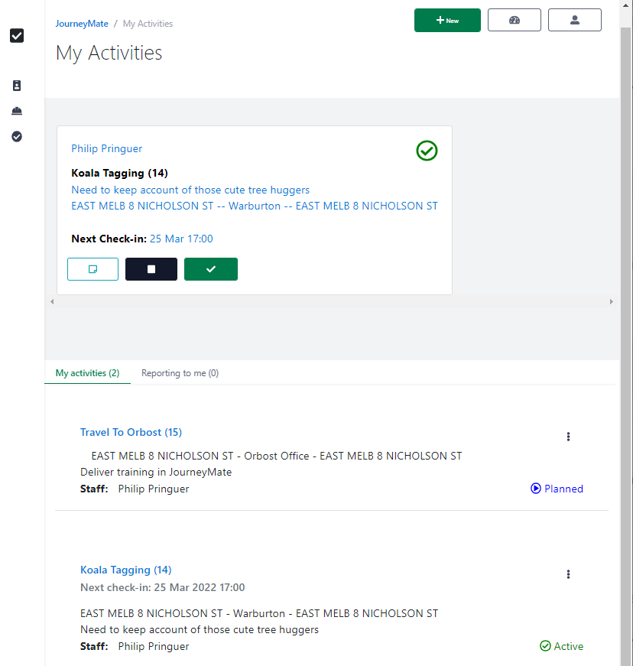
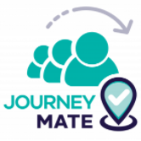

3: Profile 
One-off data entry about you, contact details, activity risk, notification preferences etc.

2: Allow location
Let your device automatically convey your location/s to JourneyMate during check-ins / check-out

4:  Activity
Change any details copied from your Profile (as required)

7: Add 
Optionally, add comments and/or record another lat/long

8: Check-out  Ends the activity, all tracking & reminders

9: Dashboard 
Access every Activity ever recorded in JourneyMate

6: Check-in 
at agreed times via app, or reminder link, or
radio-in and get someone to check-in for you via app

5: Start Activity
Click  .
Moves activity from to

1: Log-in
Tarnook > Safety & Wellbeing >
